**Criterion A: Planning**

For the Internal Assessment, I assigned my father as my advisor, who has a master’s degree in computer science and has gained experience and worked with Xerox, IBM, and HP. My client is my younger brother, who enjoys playing video games, including mobile games. As a result, my client wanted to see a product that essentially was a reconstruction of a game he enjoyed. Therefore, he requested me to re-create a game called “Flappy Bird”.

**Defining the Problem**

The video game “Flappy Bird” became a viral sensation early-2014 and was available on the iOS and Android mobile devices before being removed by its original developer. “Flappy Bird” left with at least 100 million downloads on iOS alone, and created a community of devoted players. The objective of this project is to re-create a game while discovering and understanding the basics of the educational program known as Scratch by learning from it hands-on. Since it was requested by my client, a recreation of the video game “Flappy Bird” is the aim I desire to reach. The game has a simple design with a green background, green pipes and a counter on the top of the screen.

**Rules of the Game**

1. Player will start the game by choosing the difficulty, which will affect the speed and obstacles of the game, and pressing the start button afterwards.
2. The player will gain control of the bird sprite and must take control of the bird by tapping the screen, spacebar or right-click.
3. The initial objective for the player will be to avoid the ground because if the ground is touched, the game will reset for the player, therefore, stopping the counter on the top.
4. Once the player understands this, the player will approach green pipes, which the player must avoid. If the player avoids the pipe, they gain a point for their score in return.
5. If the player hits the pipe, the game will reset and display their score and high score. The objective for the game onwards is to beat the previous personal high score.

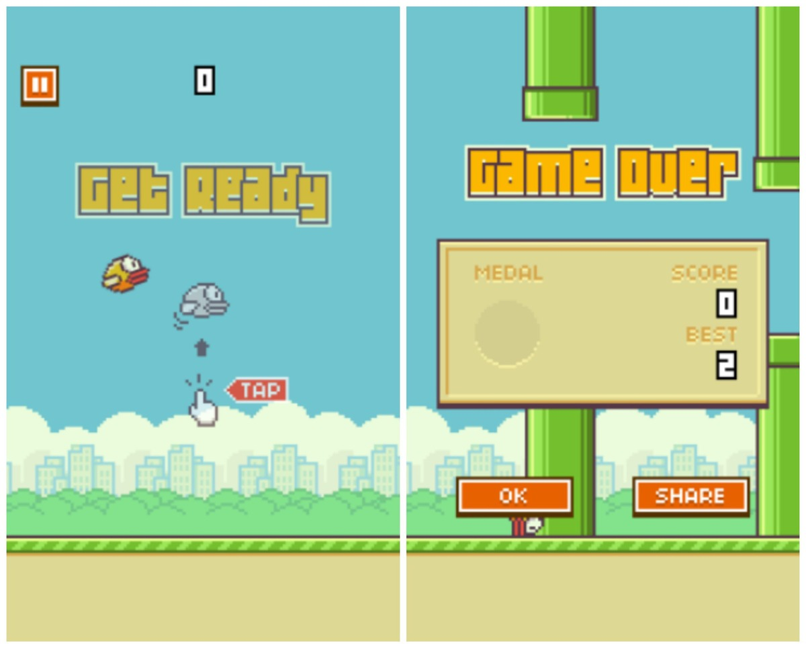

A pair screenshots of the viral game

**Purpose and Goals**

Besides the fact it was advised by my advisor, the other reason for using Scratch for my project is because of the basic user interface that will allow me to understand the elementary principles of programming in a new format. Furthermore, I understand it is essential to broaden my understanding of programming by taking advantage of different methods of learning. Also, I choose to re-create a renown mobile application because I have an interest in the development of programs on mobile device software, therefore, I can somewhat familiarize myself with the progress.

According to my goals, the final product will have the following attributes in order to be considered a success:

* The program can compile and run.
* The program can follow the instructions of the game.
* The product will have a clear graphical representation.
* The computer is able to produce the objects in the game in the correct location.
* The computer is able to remember the score of the player.
* The product will be easy and simple to access and use.
* The player will experience well-coordinated reactions from the program.
* The player will experience favorable gameplay.

**Word Count:** 548